© One Source Unlimited Inc, dba Hanson Muscle Therapy 2015, all rights reserved

HMT’s Definition of STRESS: The Cause of Pain and Suffering

Stress is clinically defined as a state of physical, mental or emotional strain or suspense. While the definition of stress can vary from person to person, generally speaking, stress is the reaction or response to external or internal challenges in our lives. These changes can be real or perceived. Our body handles these external or internal challenges in various ways. For most, this is when we experience pain in our back, neck, head, muscles, tendons, ligaments, and joints. In my years of experience, excessive stress is the cause of all injury and pain. All stress will cause tension in our body and eventually lead to disease.

The broader definition of stress is widely known. What is more compelling is the understanding that within the definition of stress, there are five forms of stress that must be defined so that we can understand the link to well-being and performance.

What follows is our definition for each form of stress as defined by HMT and its accompanying results.

- Physical stress can come from two sources: Direct trauma or Micro trauma.
Direct trauma comes from an impact - hitting or being hit by something - and sudden, uncontrolled body movement, for example, a whiplash. It causes immediate tension and tissue damage, disturbing blood flow and nerve signaling. This leads instantly to inflammation and pain.
Micro trauma is accumulated structural strain that causes tension, and eventually, tissue damage with injury and pain. Micro trauma is caused by repetitive movement patterns, improper movement patterns, and poor posture. We have all, at one time or another, used, overused, or abused ourselves physically by doing too much. Afterward, tension and pain remind us of our past action.

- Nutritional or chemical stress is another form of stress. Deficiencies, such as poor diet, lack of essential nutrients, and dehydration, will cause stress to our metabolism as well as inhibit our ability to rebuild new cells that have been damaged by our daily stress. Excessive stress in the form of poor nutrition causes tissue breakdown, with dysfunction, injury and disease as well as premature aging. Nutritional deficiencies also weaken our immune system. Excesses of toxins, chemicals, drugs (medicinal or recreational), sugar, and fat will cause tension and stress to our digestive organs, blood vessels and through reflex, a secondary tension in reflex points with pain along the surface of our body.

- Environmental stress is caused by our external surroundings. For example, an excess of bacteria, viruses, or allergens activate and stress our autoimmune system. This external energy can kill or overtake healthy cells to cause disease, and congest and inhibit our lymph drainage. A stagnation of metabolic waste products and congested lymph will cause a relative oxygen deprivation in our muscles. This can cause muscular contraction, tension, and pain.

- Unresolved Mental or Emotional stress, past or present, is the greatest stressor and cause of suffering. This is seen in anyone who is stuck, repeating a pattern, harboring destructive belief systems and suppressing negative emotions. Accumulated emotional stress causes chronic muscular tension and restricts circulation that, over time, will cause pain, injury, or disease.

By now you see a pattern. All forms of stress listed above cause tension and this tension undoubtedly leads to pain and suffering. Stress also causes tension and the contraction of internal organs and blood vessels. Excessive stress will, over time, cause life-threatening conditions. Unresolved, recurring, or repetitive stress causes an accumulation of tension, which leads to pain, injury, disease, and ultimately death.

The good news is that stress isn’t always bad. If applied gradually, with proper time to recuperate, stress helps us grow physically as well as mentally. For instance, weight training is stressful for the muscles involved; it causes a breakdown of muscle tissue. However, proper quantity and quality of rest and nutrition allows the body to repair the muscles that are broken down so that it can rebuild them; bigger and stronger than before. Progressive weight training is based on a balance between breaking down (stress) and building up (rest, recovery, and nutrition). Also, when the body has a healthy immune system, an invasion of an environmental stressor such as a bacteria or viruses, can be overcome. The body recovers from the attack by producing more white blood cells and making antibodies. In this way, the body gets stronger and immune to the stressor. This same principle is true for stress to the mind. Surely you have heard the saying “Whatever does not kill us, makes us stronger”.

The human body has a remarkable ability to repair and heal itself. A wound will heal unless it is picked at. The same is true of any injury or disease. When pain, injury or disease lingers or becomes chronic, it means something is still picking at the wound. To stop the picking, the stressor or stressors have to be neutralized, eliminated, avoided, or removed.

What Chinese Acupuncturists Knew Long Before Western Medicine

Thousands of years ago, some say dating as far back as 2697 B.C., Chinese medicine, and Chinese acupuncturists became aware that the dysfunction of the body and mind was intrinsically coupled with the presence of hundreds of sensitive reflex points on the surface of the body. These sensitive areas were the same or similar in all people who suffered from the same impairment. That is to say, if a number of individuals had similar symptoms, behavioral patterns, beliefs and emotions as the acupuncturist found by inquiring his patients, the conclusion was that those patients all had palpation soreness in the same reflex points. Patterns of dysfunction, pain, injury and dis-ease were discovered.

This is how the patterns of relationships among various internal organs, tissues, and body functions were observed and established. Due to those relationship patterns, the Chinese mapped several hundred reflex points on the human skin connected to each other by what they described as meridians. Meridians, they said, covered the body like an invisible network. Once those points were identified, the Chinese labeled and differentiated each of the points into two categories: acupoints and ashi points.

Acupoints
The Chinese discovered there are approximately 700 acupoints on the human body; each has an exact anatomical location and individual name. Later, in the early 1900’s, as the West discovered acupuncture, all points were given a second name for easier memorization. Each point was now numbered and named with the abbreviation of the organ and meridian to which it was related.

Ashi Points
Ashi points are hypersensitive points that occur randomly in any muscle, tendon or ligament. There are certain areas that are common locations of ashi points. The ashi points will give rise to local or referred pain when palpated. The word Ashi means; “ouch, that’s the spot” and refers to the palpation of a tender point and the patient yells out in pain. The ashi points feel like a tight band or a knot when palpated.

What is crucial to remember is that acupoints and ashi points are not physical tissue on the body, but an accumulation of tension that is located in a particular place on the body.

These points seem to act as invisible circuit breakers. An overload of any kind of physical stress, or the inability to be in harmony with one’s own circumstances; mental/emotional, environmental or nutritional stress, will cause certain circuit breakers to short-circuit and thus, create a blockage. The circulation that is supposed to go from point A to point B in the body suddenly gets stagnated at this stage of built up tension.

Ancient Therapy

The study and recognition of reflex points, as well as patterns of dysfunction, is what helped the ancient doctor find and remove the blockage so that they could restore the circulation and initiate healing.

Chinese medicine used various methods to remove a blockage. Typically these methods included:

- puncturing the blocked reflex points with needles
- mechanically breaking up the tension with digital pressure
- changing the diet
- prescribing remedy herbs
- the practice of Tai-Chi, Chi-Gong or meditation
- Teaching an individual the proper way to live in harmony with one's circumstances and environment.

Any reflex point, whether acupoint or ashi point, can be activated indirectly by other remote points and through pain referral along the meridians. An internal organ dysfunction can also cause an overload and activation of related acupoints, as well as create a short circuit and form ashi points in muscles, tendons and ligaments. Once a reflex point is activated, repeated stress to a lesser degree can increase or perpetuate local or radiating pain along its meridian.

It is less important what we call those hyper-sensitive reflex points, acupoint or ashi points. The fact is that they are all a circuit breaker that has been overloaded by stress. And this overload manifests itself as local tension, which then creates a blockage in circulation.

In HMT, all those points are detected and treated in the same fashion, so for the sake of simplifying things, they are from now on referred to as reflex points.

The Discovery of Reflex Points in Western Medicine; Trigger Points

Janet Travell, M.D. (December 17, 1901 — August 1, 1997) was an American physician and medical researcher. She was President John F. Kennedy and Lyndon B Johnson’s personal physician on staff to heal their ailing back troubles. Janet Travell is today most known for pioneering research on the concept of trigger points as the primary cause of musculoskeletal pain patterns.

During her career, Dr. Travell developed techniques for the treatment of so-called trigger points for myofascial pain. She co-authored two volumes of “Trigger Point Manuals” that are, to this day, considered the reference for all other books on the treatment of trigger points.
* Myofascial Pain and Dysfunction, The Trigger Point Manual vol 1 & 2 by Janet G.Travell M.D. and David G. Simons M.D.

The term myofascial trigger points (also known as trigger points, reflex points, or muscle knots), is used for all hypersensitive spots in a muscle, ligament, or tendon. A common characteristic of trigger points located in the muscles are palpable nodules or tight bands.

The theory of trigger points is that pain frequently radiates from points of local tenderness to broader areas. So, for example, the pain you are experiencing can be very distant from the actual trigger point itself. Travell identified what she termed “reliable referred pain patterns” which associate pain in one location with trigger points elsewhere. What is of great interest is that the referred pain patterns discovered do not follow the nerve dermatomes and is therefore not distributed by nerves. Hence, the pain is following a pathway not previously known to Western medicine.

When stress activates / overloads a trigger point, it will elicit either local tenderness or referred pain to remote areas. This pain can be reproduced when the reflex point is compressed, as when palpated with deep pressure. When an active trigger point is palpated with deep digital pressure, the patient often jumps from the discomfort. This is what is called “the jump sign” and confirms the finding of an active trigger point.

One theory is that the more acute trigger points will refer pain into distant, or distal, areas. Those referred pain zones were reproducible in different individuals, hence the establishment of distinct referred pain pattern for trigger point located in specific muscles.

Those trigger points did not have an exact anatomical location. In fact, they could occur anywhere in muscles, tendons or ligaments. But what was initially recognizable is that certain areas in particular muscles had common occurrences of trigger points. Once this was recognized and repeatable, documentation of the referred pain patterns of those common trigger points was established. Eventually, the trigger points were named after the muscle in which they were located.

Travell’s discovery of these trigger points is identical to the forgotten ancient ashi points. The referred pain patterns she discovered and documented are the same as the distribution of the Muscle Meridian’s (illustrated below) discovered by the Chinese thousands of years ago.

Meridians

Traditional Chinese Medicine teaches that all reflex points are connected directly or indirectly through pathways called meridians. Meridian charts or drawings are used to illustrate this connection. Meridians are not physical in nature, cannot be seen by the human eye, and are named after the organ, or organ system to which they are connected.

The ancient Chinese believed that pain, injury, or disease was caused by blockage or stagnation of circulation along the meridians. An old Chinese proverb illustrates this philosophy by stating:

“There is only one disease, its name is stagnation. There is only one cure, its name is circulation.”

The ancient physicians believed the human body could cure itself when circulation and harmony were restored. Treatment consisted of finding the blocked (short-circuited) reflex point and releasing the tension through digital pressure or needling to restore the circulation.

There are two types of meridians that ancient Chinese Medicine teaches us: The 12 bilateral Main Meridians and 12 bilateral Muscle Meridians.

Main Meridians

The body has twelve bilateral Main Meridians, each with a beginning and ending location and includes acupoints along its course. Those acupoints all have an exact anatomical location and their own name (for example Si 3, for Small Intestine point #3).

Meridian charts have lines connecting the acupoints to illustrate the direction and flow of energy along the human body. These twelve bi-lateral Main Meridians were thought to cover the entire surface of the human body like an invisible web. All parts of the body and mind were connected directly or indirectly to each other through this network.
Main Meridians (Chart)

Muscle Meridians

Along each of the twelve bilateral Main Meridians runs the more superficial Muscle Meridian. Muscle Meridians connect a chain of muscles, tendons, and ligaments through fascia. Fascia is defined as fibrous bands of tissue that connect and bind together muscles, tendons and ligaments like a plastic cling wrap. The Muscle Meridians follow a similar path as its related Main Meridian and cover the entire human body. The Muscle Meridians overlap each other so that all of the skeletal muscles are part of one or more Muscle Meridian. The muscle meridian itself is not the actual tissue of the muscles, tendons, ligaments or fascia, but rather the circulation and electrical current that runs through them. It is along those Muscle Meridians that ashi (trigger points) can form when there is an overload/stress to the body or mind. Those short circuited and overloaded reflex points immediately cause the muscles and tissue they are located in, to contract. Once a reflex point has been short-circuited due to an overload of stress, it can refer pain along the distribution of the muscle meridian(s) they are located in.
Muscle Meridians (Chart)

Acupuncture and Acupressure Today

Today acupuncture and acupressure is recognized by the World Health Organization (WHO) and practiced all over the world. It is used for a variety of symptoms; most commonly to treat pain, but also as a valuable therapy for:

- Musculoskeletal and Neurological problems such as headaches, neck and back pain.
- Asthma, sinusitis and other respiratory conditions.
- Digestive problems such as colitis as gastritis.
- Persistent menstrual problems.
- Addictions to alcohol, cigarettes, and some drugs.

Acupuncture is also used as a natural anesthetic. Modern research suggests that mechanical stimulation (needle or digital pressure) of an acupoint can cause nerve cells to release endorphins as a natural pain reliever.
In traditional Chinese medicine (TCM), the diagnosis and selection of points to treat is done primarily through pulse diagnosis. In this ancient diagnostic method, the practitioner is detecting different nuances in the patient’s pulse that deviates from a healthy pulse pattern. There are different locations to palpate the pulse that relates to each of the twelve meridians/organs. Those nuances are described, named and all have a certain set of points to treat to restore a healthy pulse, give pain relief, and initiate healing. In TCM, it is said that it takes a man age (40 years) of practice to master pulse diagnostics. Finding the right point(s) to treat for every injury and every pain depends on the intuitive skill of each individual practitioner of acupuncture. If the right points are selected, the results can be astonishing and immediate.

A modern approach to acupuncture and acupressure is to select the points to treat based on a less effective “cookbook” approach, where a predetermined set of points are used to treat a particular symptom in all people.

The ancient writing stated that the master could find the right point to treat and have immediate results. This ancient skill of selecting the right point(s) for immediate healing seems to be a lost art in today’s practice of acupuncture and acupressure.

Due to the discrepancy in selecting points to treat among different practitioners, and the unique condition of each patient case, acupuncture and acupressure do not work well with double-blind studies (the scientific model used to prove if something works in Western medicine). Obviously acupuncture and acupressure is of great benefit for healing or it would not have survived time and spread worldwide. Results are, however, not always reproducible and depend heavily on the intuitive skill of each individual practitioner.

Another thing that seems to have been lost from the ancient practice is the ability to teach the patients about cause and effect of their pain and suffering, as well as teaching the proper way of life for healing that lasts.

Western science (not willing to accept the existence of acupoints and meridians that are not physical in nature) has found that a change in electrical resistance and temperature can be found on the surface of the body. This can be scientifically measured with an ohmmeter (measures electrical resistance) or thermogram (an imaging test that captures heat radiating from a person’s body) and can also be seen on Kirlian photography (photographic technique that captures the phenomena of electrical discharges). Scientists were concerned over the fact that the same areas did not show up in all people and for this reason were not reproducible.

This, however, would make perfect sense with our model of explanations since only the overloaded, short-circuited points have a build up excessive electrical charge. Those overloaded reflex points will not be the same in all people. They are the sites of stagnated circulation and accumulated tension that is different in each individual from moment to moment. This buildup of tension in a short-circuited reflex point causes a blockage of circulation and is followed by dysfunction (a buildup of tension) in connected muscles, joints, nerves, and organs, as well as in our mind, leading to pain, injury, and disease.

Western science has conducted research that suggests the effects of acupoint treatment is due to the body’s release of endorphins (analgesic effect) when the points are stimulated. This research has been inconclusive since pain relief is not consistently achieved and, since western science does not accept the concept of the acupoints and meridians, acupuncture and acupressure remain a mystery.

Trigger Point Therapy Today

Trigger point therapy is practiced today by chiropractors, physical therapists, athletic trainers and body workers all around the world.

The trigger points are found and localized more by accident as stumbling on an acute trigger point with referred pain pattern while palpating or massaging a patient. Finding and treating all related trigger points that may be primary or secondary to the point they stumbled on, is more by chance than by design. Recognizing pain patterns and trying to memorize points that may be related to the point they found may be used. Not clearing all trigger points related to each other or teaching the patient the cause of tension so they can avoid building up tension again, are cause for the pain and injury to return.

Finding, treating, and releasing all trigger points related to an injury remain the main problem with getting lasting results with trigger point therapy.

HMT a Bridge between Ancient East and Modern West

HMT is a new approach to ancient acupuncture, as well as trigger point therapy, where detection of tension in the skeletal muscles is used to select the primary points to treat for immediate results. The tension in skeletal muscles is detected through observation of posture, range of motion and manual muscle testing, and reveals an individual’s muscular imbalance. The incorporation and knowledge of the muscle meridians assure the finding and treating of all reflex points related to an injury for superior and lasting results.

Muscular Imbalance

The core diagnosis in HMT is muscular imbalance. In the HMT approach to wellness, muscular imbalance is present in the place where our body holds its greatest tension. This tension or blockage of circulation is the root of our pain, discomfort, injuries, decreased performance and declining health.

Muscular imbalance is the idea that there is an uneven pulling force on a joint or a limb. So much so that this uneven pulling throws out of balance the natural synergy between the two types of muscle groups in our body. Those muscle groups are synergists or antagonists.

Synergists are muscles that, during contraction, work together to promote movement in a specific direction of a joint or a limb. For example, the biceps, brachialis, and brachioradialis are muscles on the arm that all bend the elbow. The triceps muscles and the anconeus are all synergist muscles that straighten the elbow.

Antagonists are muscles that pull and cause movement in opposite directions. The two groups oppose each other and are each other’s antagonists. The biceps and triceps are antagonists to each other.

It is very important that there is an intrinsic strength balance between antagonistic and synergistic muscles to promote optimal performance, flexibility, strength, and endurance as well as health and well-being. For a muscle to reach its strength potential it has to be balanced. A balanced muscle must be able to shorten (contract) and lengthen (stretch) within its full range. A balanced muscle is able to oppose but not overpower the force from its antagonistic muscle(s), like a balanced see-saw. When there is excessive tension in one or more muscles, the balance or harmony is lost. Muscle tension causes pain due to a deprivation of oxygen in the tensed muscles. This contraction leads to more pain due to an increased pulling force on the muscle’s tendons and increased strain to its surrounding ligaments.

Muscles in Imbalanced State

A muscle in an imbalanced state is going to be either too short (contracted or hypertonic) or too long (elongated or hypotonic). For conversations’ sake, it is hard to say what came first; did the short muscle fatigue its antagonistic muscle(s) and hence cause it to lengthen, or did the lengthening of a muscle cause its antagonistic muscle(s) to shorten because a lack of opposing pulling force?

This is like asking which came first; the chicken or the egg. While it is fun to posit this question, it is merely an exercise in redundancy. What is important is to understand that these things happen together.

The short muscle(s) will pull the joint or limb in the fiber direction of the muscle contraction by a lack of opposition in the antagonistic elongated muscle(s). The short muscle will be relatively strong compared to its antagonist. The long muscle will be relatively weak compared to its antagonist. It is important not to confuse this relative strength imbalance within a closed unit of antagonists as one strong and one weak muscle; in fact both of those muscles are weak since neither can both fully contract and fully stretch.

Anytime there is muscle shortening, and subsequent muscle lengthening of the antagonistic muscles, there is a muscular imbalance. In other words, the body is out of alignment.

We can make the comparison with the human body being out of alignment with a car being out of alignment. The wheels of a car have to be balanced to prevent the car from being pulled to the right or to the left. When the tires are not balanced, it will affect the performance of the car, cause uneven wear of the tires as well as accelerate wear, tear and breakdown of the car.

Every joint in the human body, including the joint surface between each of the spinal vertebrae, is supported and surrounded by muscles that promote stability and movement of the joint or a limb in different planes or directions. When the muscles of a joint are not balanced, it will accelerate wear, tear and breakdown, thus causing pain, injury, and disease.

In HMT, the primary muscles to treat are the shortened, hypertonic muscles.

Muscle shortening causes the following types of issues:

- Decreased range of motion
- Postural imbalances
- Changed joint positions with decreased joint space
- Decreased vascular circulation, oxygen deprivation
- Inhibition of lymphatic drainage
- Nerve compression or friction, leading to neuropathy (dysfunction) and radiating pain
- Decreased strength and endurance
- Pain and inflammation.

Overall, it is worth remembering that Muscular Imbalance affects not only the function, performance, and health of a person, but in the end, affects a person’s well-being. Over and over we hear the phrase uttered: “That person is an accident waiting to happen”. That is because their muscular imbalance is making them prone to certain injuries. And, over time, their muscular imbalance becomes chronic, leading only to neuropathy, joint pathology, and joint degeneration.

How the software HMT will help the provider ‘Get to the Point’

The HMT allows the provider to read feedback from the patient’s body to detect areas of accumulated tension. The location of tension is not always the same as the site of pain. Identifying and treating the location of primary tension restores circulation with immediate pain relief. The sites of primary tension in the patient are what lead to the existing pain and injury. HMT also helps the provider locate areas prone to injury, or areas that will be susceptible to injury. In this way, HMT also provides preventative care to align the body for optimal performance.

The reading of muscle tension feedback is done initially with a Range Of Motion Assessment, Postural Evaluation and through Manual Muscle Testing of individual muscles. Those three examinations are used to evaluate and read exactly where the patient is holding their tension/stress. Each range of motion limitation and/or postural fault and each manual Muscle Test indicate which muscles are tense, short and contracted. It is in those shortened muscles the overloaded reflex points are found.

Due to the complexity and many combinations of muscular imbalances and muscles/reflex points to treat, Tobe Hanson developed online software to help providers compute the most efficient treatment for fast and superior results. This online HMT software is called “Get to the Point” and is available on this website to providers for annual or monthly subscriptions.

The HMT software uses the feed of muscular imbalance data (areas of accumulated stress / tension) to give the practitioner a custom-made prescription on primary active Reflex Points, Muscle Meridians and muscles to treat for every individual case.

Treatment of the reflex points and muscles prescribed by the HMT software will assure selecting the primary points to initiate immediate pain relief, restore function and administrate preventative care for optimal performance.

With over a thousand points to choose from and unlimited combinations of points to treat, HMT takes away the guesswork or the “hit and miss” approach. The treatment, re-setting the circuits, and therefore releasing the tension based on this prescription, will be customized and give the patient immediate pain relief, restored function and improved performance.

Indicator Muscle Testing used for Therapy Localization of Active Reflex-Points

Once the prescription of reflex points, muscle meridians and muscles to treat has been established according to the HMT evaluation, the exact location of the overloaded reflex point(s) has to be determined. This is done through an indicator muscle test response called therapy localization. Therapy localization indicates when the provider or patient touches an area simultaneously as an indicator muscle is tested for response. A slight twitch or noticeable weakness in resistance of the tested muscle indicates a positive therapy localization. Meaning, the area touched needs to have therapy applied to it. Therapy localization tells us were to apply therapy.

In HMT, therapy localization is used for instant feedback in finding the exact location of a trigger or acupoint that needs therapy. This test takes away the “hit and miss” approach in locating the primary reflex points to treat. There is a generalized effect on muscles of the body when there is positive therapy localization. When a muscle remote from an injured area is used to evaluate therapy localization, it is called an indicator muscle. An indicator muscle test is of great value when screening a patient for charged reflex points.
First a muscle is tested to determine if it is able to maintain its contraction (hold the position) without therapy localization. This is known as testing a muscle ‘in the clear’. If the muscle is strong and the test does not elicit pain, then it can be used as an indicator muscle.
For example, a neutral muscle on the left side opposite a shoulder injury on the right side is used as an indicator muscle. This muscle, for example, the left Anterior Deltoid or Pectoralis Major Clavicular, is tested ‘in the clear’. To therapy localize for reflex points related to the right shoulder injury, the provider touches the skin of all muscles and muscle meridians indicated by the HMT evaluation and software program.

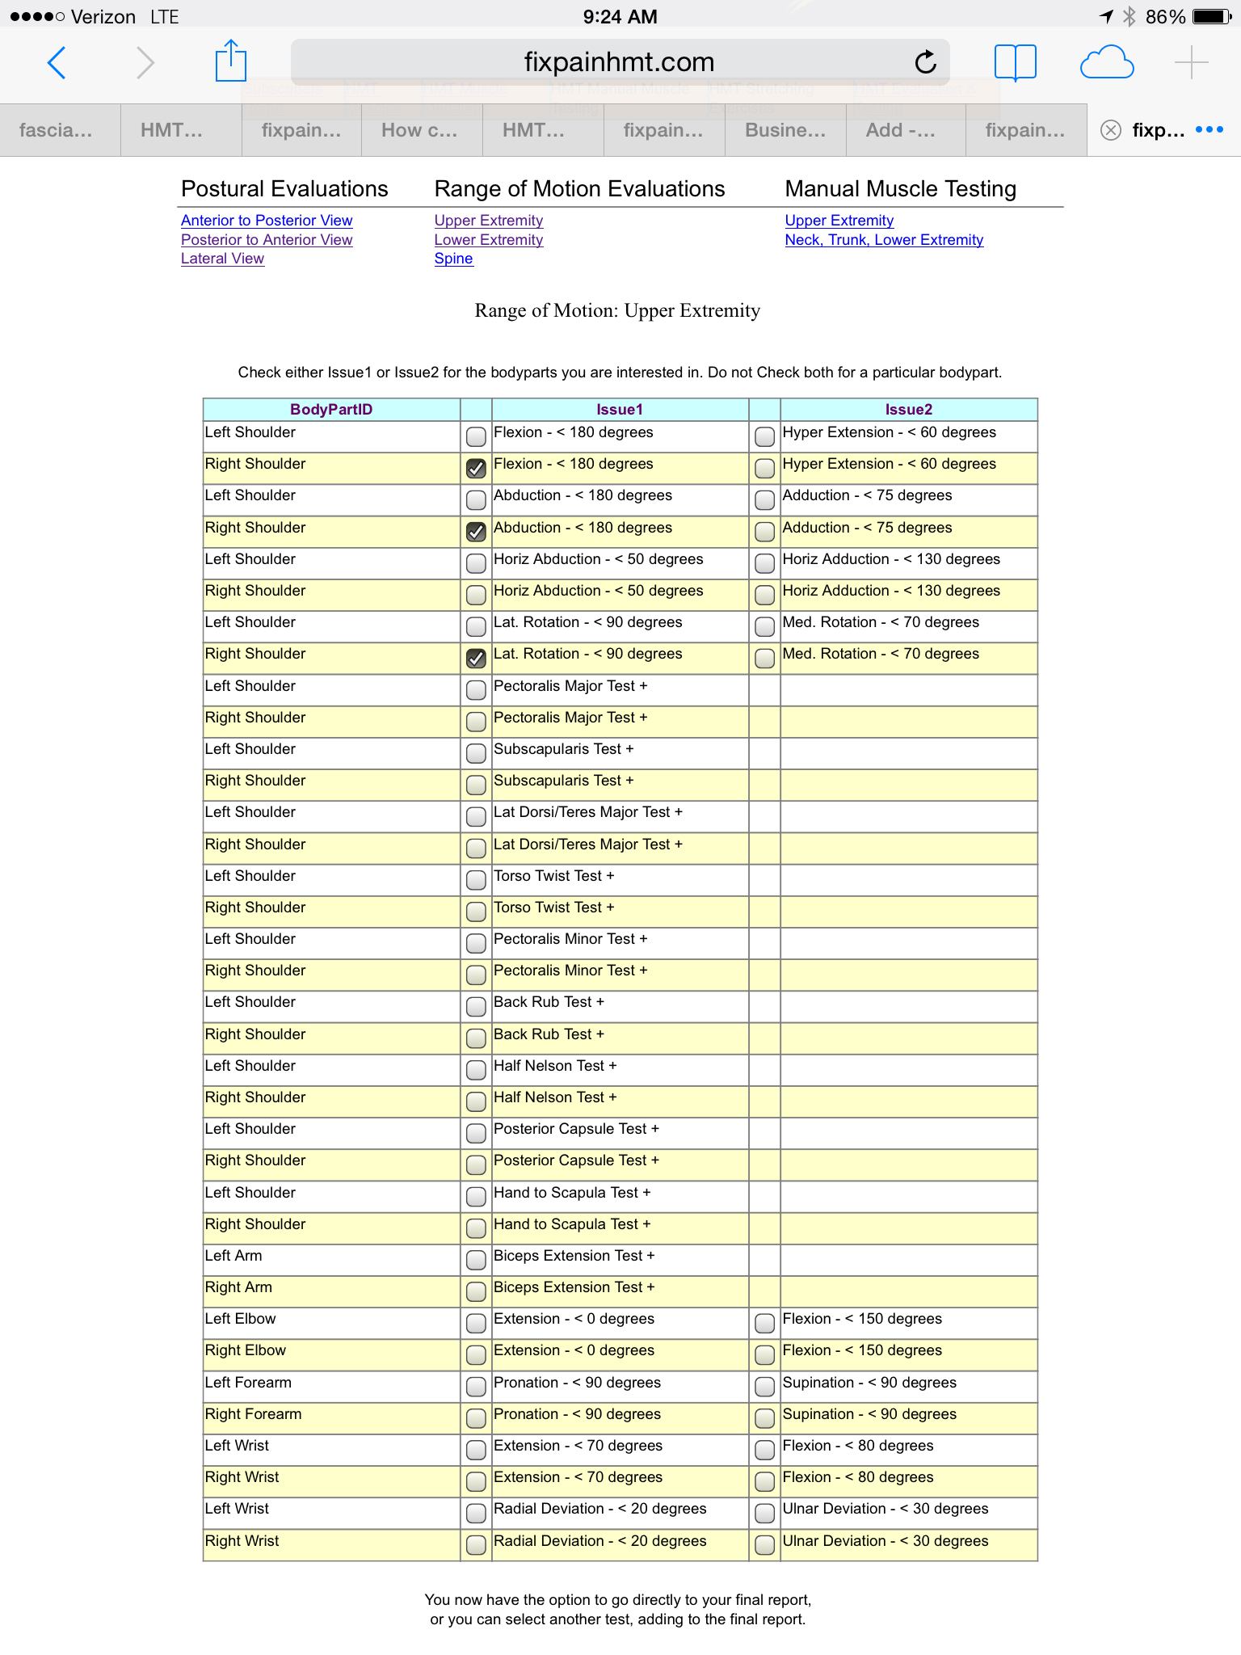

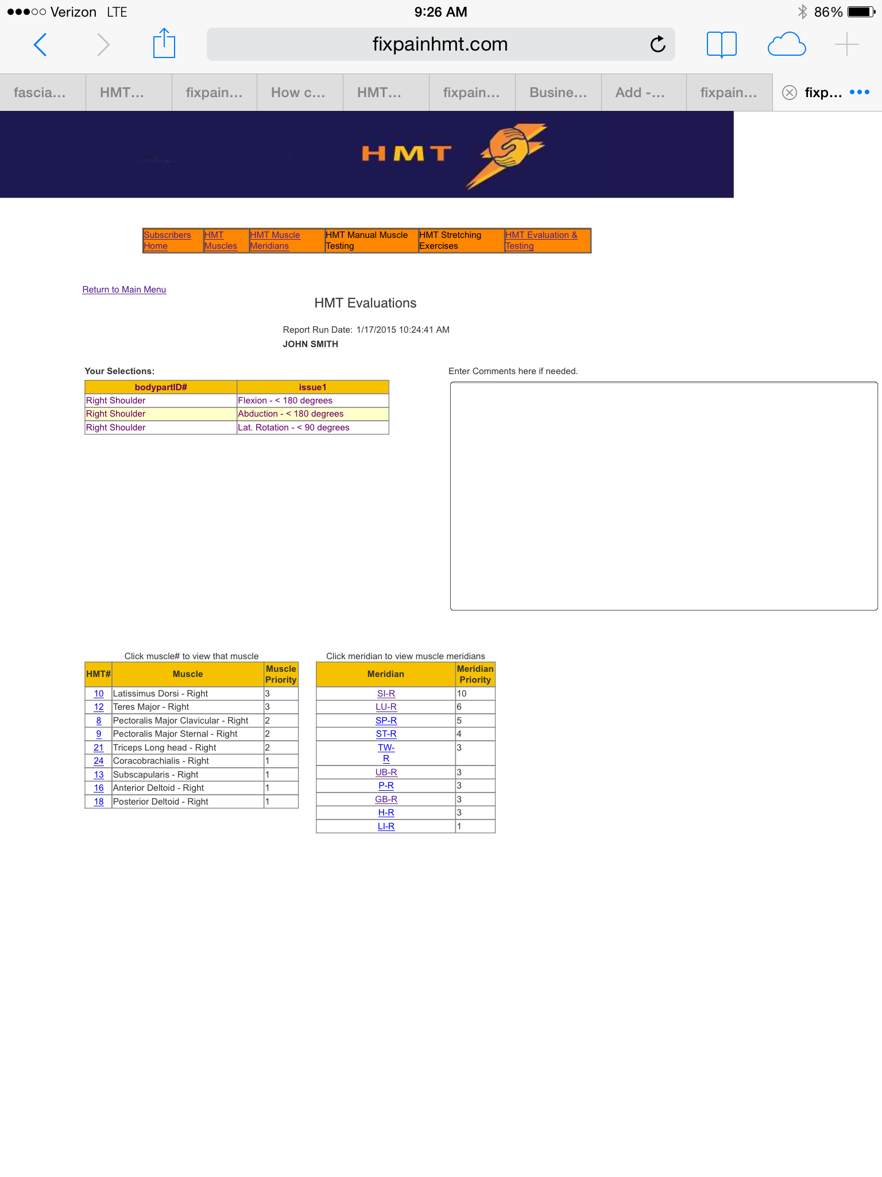

According to the example, the Latissimus Dorsi and Teres Major and the SI (Small Intestine) muscle meridian have the highest priority for treatment. The provider slowly scans the skin surface over those muscles, one at a time, or scans along the Small Intestine muscle meridian while simultaneously testing the indicator muscle of the patients left shoulder.
A slight twitch or noticeable weakness (positive therapy localization) is detected in the tested indicator muscle when the provider is touching an active reflex-point indicating a primary point that needs to be treated. This may be repeated over the entire surface of those muscles and/or the SI muscle meridian. There is a positive test any time the indicator muscle tests weak.
Reflex-Point Inactivation
Deep pressure to an active reflex-point will elicit pain. The provider cannot feel the pain but rather the tension. It is very important that the patient is assured that he or she is the one who determines the amount of pressure being applied. They are recommended to use the words “stop” or “go lighter”. It is important that the provider acknowledge the patient’s wishes to build trust and avoid the possibility of the patient feeling violated. Different people have different pain tolerances. It is possible to work on a 5-year-old child, an 80-year-old woman, or a 250 lb professional football player and have success with any ailment related to myofascial tension.
Once a primary reflex point has been localized, it should be released of its excessive tension with deep friction massage. Deep intermittent digital pressure to a reflex point in a specific direction causes a form of depolarization. Digital pressure on a primary reflex point will elicit local and/or referred pain. Complete release of tension with digital pressure to a reflex point will cause all elicit pain to completely disappear. This will lead to immediate pain relief and restored function.
The patient will soon notice that when the painful point is being worked on it suddenly releases and a warmness, tingling or general feeling of goodness is experienced. A form of depolarization appears to take place as the tension is released in the active reflex point. As the patient becomes more familiar with the phenomena, he or she may actually start liking this sensation which means they may allow for greater pressure and greater initial pain as the therapy continues to other reflex points.
As a provider, you cannot feel their pain but will feel the tension and how it is being released. It will feel as if the point was a hard piece of ice that suddenly melts and disappears. As a provider becomes more skilled, he or she can actually tell the patient when it starts to feel better since the release of tension will be followed by simultaneous relief of pain.

Digital Application

In HMT, two fingers supporting each other are used to apply pinpoint pressure with the tip of one of those two fingers, usually the middle finger. In some cases when the reflex point is in a deep and/or large muscle, the tip of the provider’s elbow may be used.

HMT Selects Primary Points

HMT software is capable of selecting primary points for each individual condition by reading the patient’s muscular imbalances. Using the HMT software and indicator muscle testing for exact therapy localization takes away the guesswork and the “hit and miss” approach.

The HMT treatment of finding and re-setting the circuit’s (releasing the tension), will be customized and give the patient immediate Pain Relief, Restored Function and Improved Performance.

